TASK1:

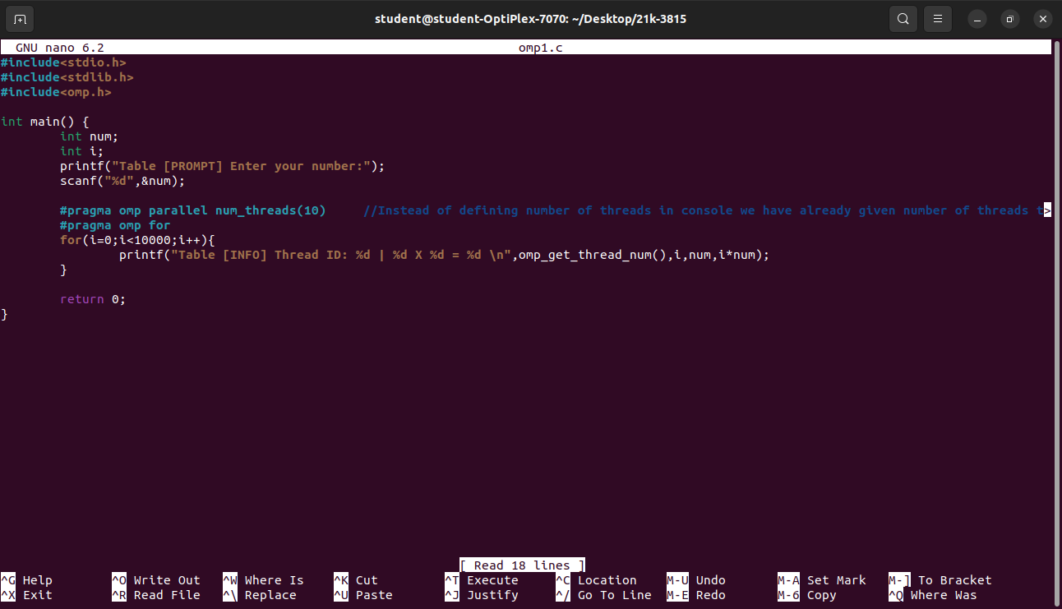
TASK 2: Explain the result why the result is change when number of threads change
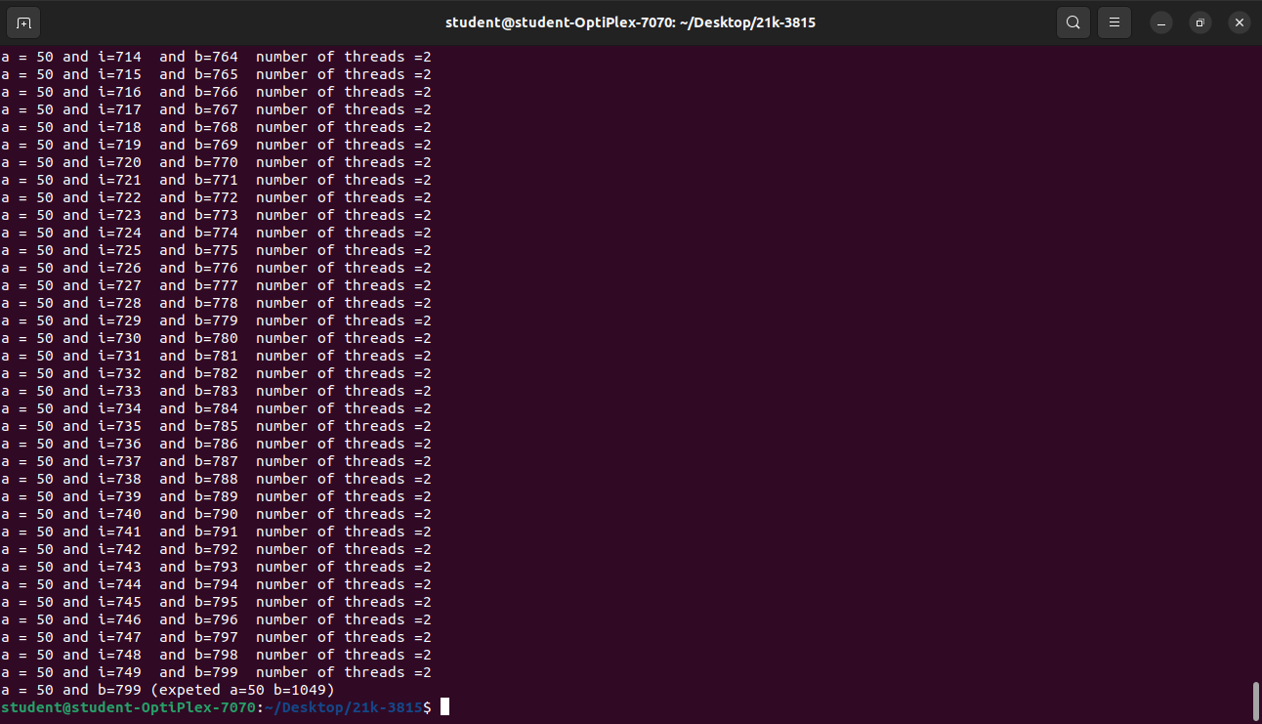
ans : since all the threads are entering race condition at the same time thus the updating value gets override thus the value of b changes.

